

Section B | FA24-BCS-068

OOP

Muhammad Hammad Sarwar

Assignment # 3



MAY 08, 2025

Submitted to: MUHAMMAD SHAHID

**OUTPUT SCREEN SHOTS:**

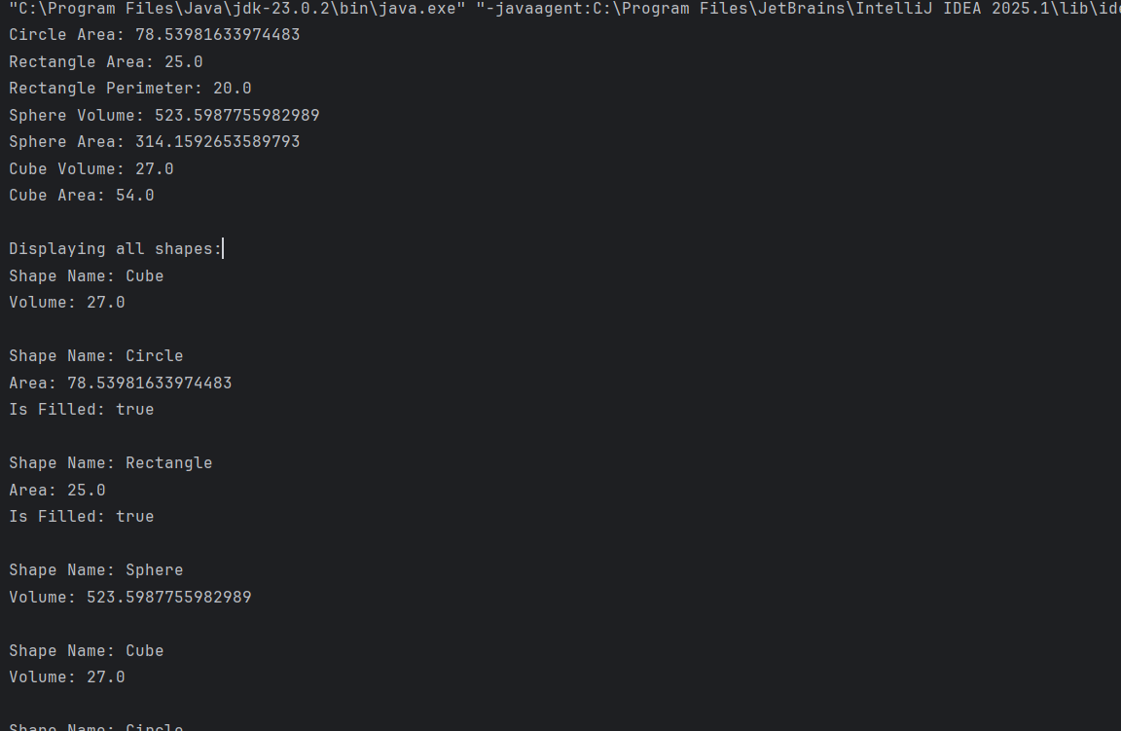

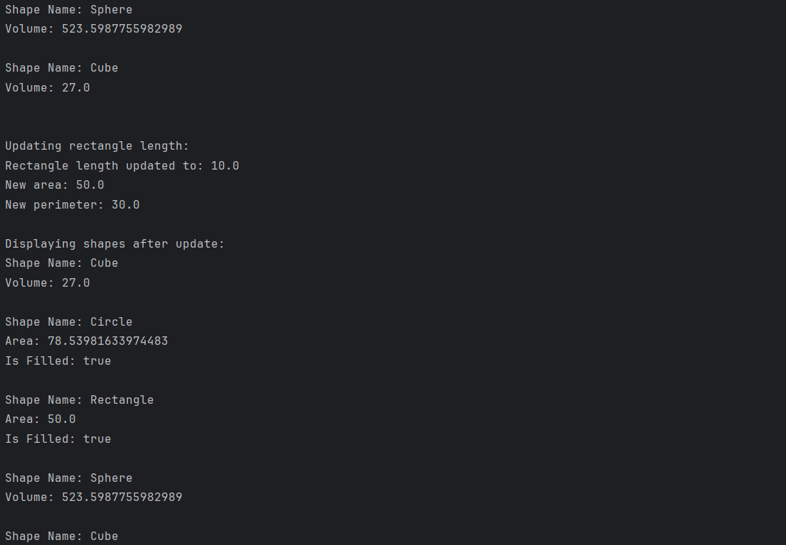

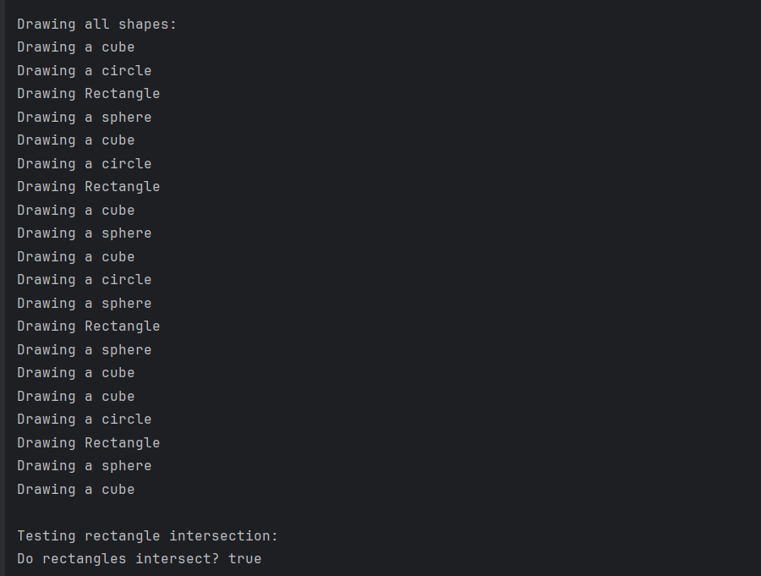

**CODE:**

import java.util.Arrays;  
  
public class Main {  
 public static void main(String[] args) {  
 Shape shape;  
 Shape2D shape2D;  
 Shape3D shape3D;  
 Shape[] shapes = new Shape[20];  
   
 Shape2D circle1 = new Circle("Circle", true, 5.0);  
 System.*out*.println("Circle Area: " + circle1.area());  
   
 shape2D = new Rectangle("Rectangle", true, 5.0, 5.0);  
 System.*out*.println("Rectangle Area: " + shape2D.area());  
 System.*out*.println("Rectangle Perimeter: " + ((Rectangle) shape2D).perimeter());  
   
 Shape3D sphere1 = new Sphere("Sphere", true, 5.0);  
 System.*out*.println("Sphere Volume: " + sphere1.volume());  
 System.*out*.println("Sphere Area: " + ((Sphere) sphere1).area());  
   
 Shape3D cube1 = new Cube("Cube", 3.0);  
 System.*out*.println("Cube Volume: " + cube1.volume());  
 System.*out*.println("Cube Area: " + ((Cube) cube1).area());  
   
 // array  
 shapes[0] = cube1;  
 shapes[1] = circle1;  
 shapes[2] = shape2D;  
 shapes[3] = sphere1;  
 shapes[4] = cube1;  
 shapes[5] = circle1;  
 shapes[6] = shape2D;  
 shapes[7] = cube1;  
 shapes[8] = sphere1;  
 shapes[9] = cube1;  
 shapes[10] = circle1;  
 shapes[11] = sphere1;  
 shapes[12] = shape2D;  
 shapes[13] = sphere1;  
 shapes[14] = cube1;  
 shapes[15] = cube1;  
 shapes[16] = circle1;  
 shapes[17] = shape2D;  
 shapes[18] = sphere1;  
 shapes[19] = cube1;  
  
 // After the shapes array  
 ShapeUtils utils = new ShapeUtils();  
 System.*out*.println("\nDisplaying all shapes:");  
 utils.displayShapes(shapes);  
  
  
 System.*out*.println("\nUpdating rectangle length:");  
 utils.updatelenght(shape2D, 10.0); // Updates length to 10.0  
 System.*out*.println("\nDisplaying shapes after update:");  
 utils.displayShapes(shapes);  
  
 System.*out*.println("\nDrawing all shapes:");  
 ShapeUtils.*drawDrawable*(shapes); // shapes array can be used as Drawable array since Shape implements Drawable  
  
 // intersection test  
 System.*out*.println("\nTesting rectangle intersection:");  
 Rectangle rect1 = new Rectangle("Rectangle 1", true, 5.0, 3.0);  
 Rectangle rect2 = new Rectangle("Rectangle 2", true, 4.0, 2.0);  
   
  
 rect2.topLeftCorner.setX(2);  
 rect2.topLeftCorner.setY(2);  
   
 System.*out*.println("Do rectangles intersect? " + rect1.intersects(rect2));  
 }  
}